**Azure Terraform DevOps**

Project Steps

General Steps by Waynewright S.

Terraform is an open-source infrastructure as code (IAC) tool that allows users to define and deploy infrastructure resources, such as servers, storage, and networking, using simple, human-readable configuration files.

**Azure Provider**

The Azure Provider can be used to configure infrastructure in Microsoft Azure using the Azure Resource Manager API’s.

Docs: <https://registry.terraform.io/providers/hashicorp/azurerm/latest/docs>

Click → Service Principal and a Client Secret

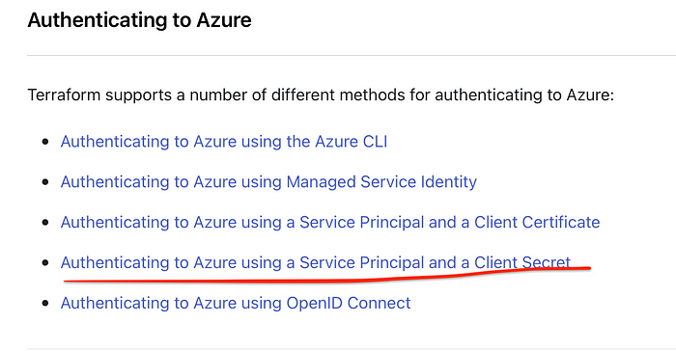

Login to the CLI in VSCode. Automatically rediret the browser enter your azure credentials.

az login

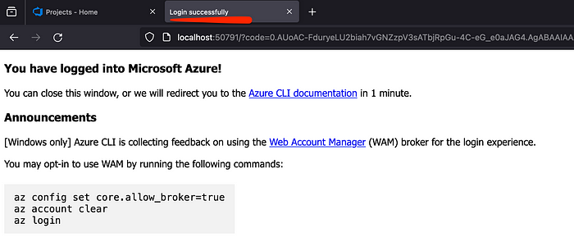

Successfully logged in Azure DevOps portal via VSCode Terminal

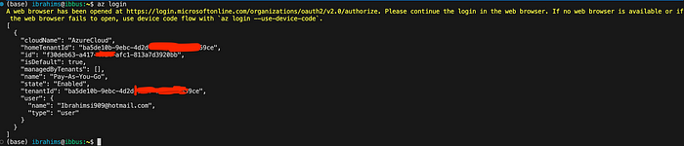

allow users to download data exported from the plan of a Run in a Terraform workspace.

export MSYS\_NO\_PATHCONV=1

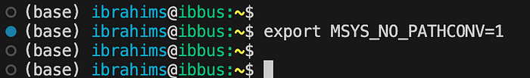

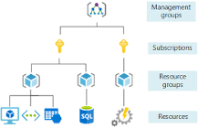

Organizations can use subscriptions to manage costs and the resources that are created by users, teams, and projects.

az ad sp create-for-rbac --role="Contributor" --scopes="/subscriptions/20000000-0000-0000-0000-000000000000"

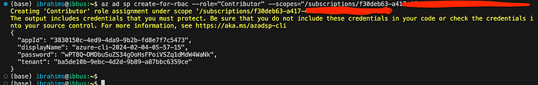

An Azure service principal is an identity created for use with applications, hosted services, and automated tools to access Azure resources. This access is restricted by the roles assigned to the service principal, giving you control over which resources can be accessed and at which level.

Create a Service Principal

These values map to the Terraform variables like so:

* [appId](https://registry.terraform.io/providers/hashicorp/azurerm/latest/docs/guides/service_principal_client_secret#appId) is the client\_id defined above.
* [password](https://registry.terraform.io/providers/hashicorp/azurerm/latest/docs/guides/service_principal_client_secret#password) is the client\_secret defined above.
* [tenant](https://registry.terraform.io/providers/hashicorp/azurerm/latest/docs/guides/service_principal_client_secret#tenant) is the tenant\_id defined above.

az login --service-principal -u CLIENT\_ID -p CLIENT\_SECRET --tenant TENANT\_ID

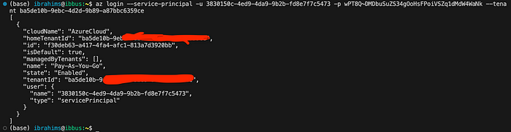

Successfully login the Service Principal account

**How Terraform Works?**

Terraform creates and manages resources on cloud platforms and other services through their application programming interfaces (APIs).

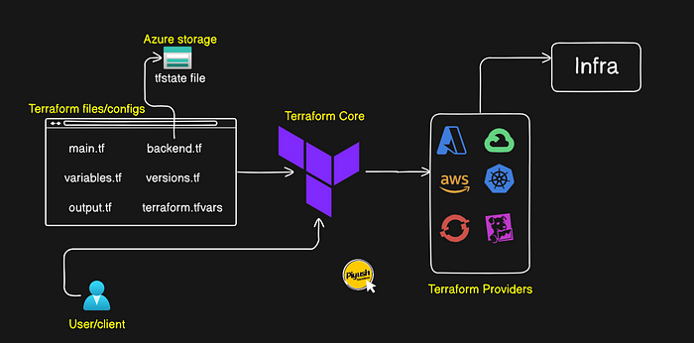

**main.tf**: This is our main configuration file where we are going to define our resource definition.

**variables.tf**: This is the file where we are going to define our variables.

**outputs.tf**: This file contains output definitions for our resources

**backend.tf**: Defines where the state file of the current infrastructure will be stored (or) where Terraform stores its state data files

Terraform keeps track of the managed resources. This state can be stored locally or remotely.

This State File contains full details of resources in our terraform code. When you modify something on your code and apply it on cloud, terraform will look into the **state file**, and compare the changes made in the code from that state file and the changes to the infrastructure based on the state file.

When you run **terraform apply** command to create an infrastructure on cloud, Terraform creates a state file called “**terraform.tfstate**”.

version.tf: Terraform will check **that the version of the installed Terraform binary that executes the Terraform configuration.**

**terraform.tfvars: allow us to manage variable assignments systematically in a file with the** extension .tfvars or .tfvars.json

Terraform core → Core is responsible for life cycle management of infrastructure.

Terraform Provider → **A plugin for Terraform that makes a collection of related resources available**

**Initialize the Terraform repo**

Initializes the Terraform working directory, downloading any necessary provider plugins.

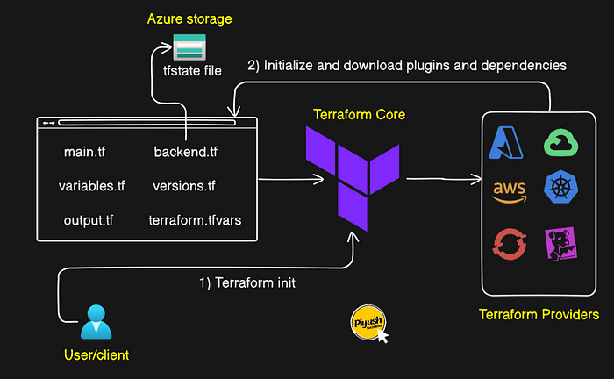

**Run Terraform plan**

Terraform plan command creates an execution plan, which lets you preview the changes that Terraform plans to make to your infrastructure.

When Terraform creates a plan it → Reads the current state of any already-existing remote objects to make sure that the Terraform state is up-to-date.

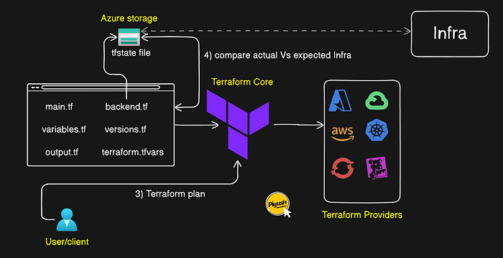

**Run Terraform apply**

Create the AWS resources defined in your Terraform configuration

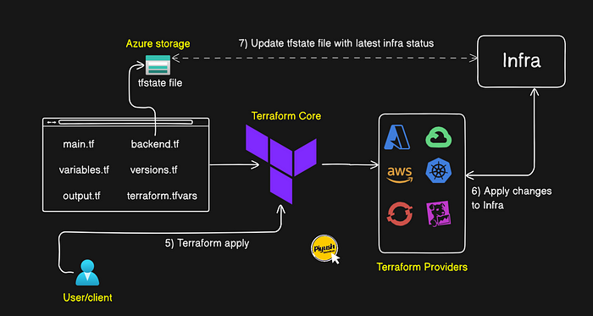

**Import the below repository into Azure DevOps for Terraform configuration**

**[GitHub - Ibrahimsi/Terraform-AzureDevOps-Sample](https://github.com/Ibrahimsi/Terraform-AzureDevOps-Sample.git?source=post_page-----b57005a37936--------------------------------" \t "_blank)**

[Contribute to Ibrahimsi/Terraform-AzureDevOps-Sample development by creating an account on GitHub.](https://github.com/Ibrahimsi/Terraform-AzureDevOps-Sample.git?source=post_page-----b57005a37936--------------------------------" \t "_blank)

[github.com](https://github.com/Ibrahimsi/Terraform-AzureDevOps-Sample.git?source=post_page-----b57005a37936--------------------------------" \t "_blank)

(OR) Create a file manually

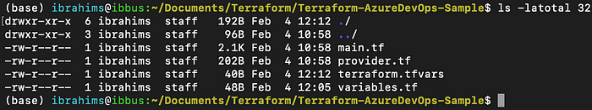

Displays directory paths and (optionally) files in each subdirectory: *tree*

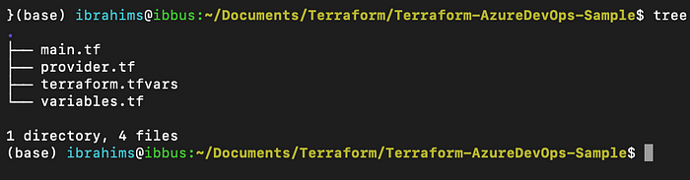

main.tf: This is our main configuration file where we are going to define our resource definition.

resource "azurerm\_resource\_group" "example" {  
 name = "${var.prefix}-rg"  
 location = var.location  
}  
  
resource "azurerm\_virtual\_network" "main" {  
 name = "${var.prefix}-network"  
 address\_space = ["10.0.0.0/16"]  
 location = azurerm\_resource\_group.example.location  
 resource\_group\_name = azurerm\_resource\_group.example.name  
}  
  
resource "azurerm\_subnet" "internal" {  
 name = "internal"  
 resource\_group\_name = azurerm\_resource\_group.example.name  
 virtual\_network\_name = azurerm\_virtual\_network.main.name  
 address\_prefixes = ["10.0.2.0/24"]  
}  
  
resource "azurerm\_network\_interface" "main" {  
 name = "${var.prefix}-nic"  
 location = azurerm\_resource\_group.example.location  
 resource\_group\_name = azurerm\_resource\_group.example.name  
  
 ip\_configuration {  
 name = "testconfiguration1"  
 subnet\_id = azurerm\_subnet.internal.id  
 private\_ip\_address\_allocation = "Dynamic"  
 }  
}  
  
resource "azurerm\_virtual\_machine" "main" {  
 name = "${var.prefix}-vm"  
 location = azurerm\_resource\_group.example.location  
 resource\_group\_name = azurerm\_resource\_group.example.name  
 network\_interface\_ids = [azurerm\_network\_interface.main.id]  
 vm\_size = "Standard\_DS1\_v2"  
  
 # Uncomment this line to delete the OS disk automatically when deleting the VM  
 # delete\_os\_disk\_on\_termination = true  
  
 # Uncomment this line to delete the data disks automatically when deleting the VM  
 # delete\_data\_disks\_on\_termination = true  
  
 storage\_image\_reference {  
 publisher = "Canonical"  
 offer = "0001-com-ubuntu-server-jammy"  
 sku = "22\_04-lts"  
 version = "latest"  
 }  
 storage\_os\_disk {  
 name = "myosdisk1"  
 caching = "ReadWrite"  
 create\_option = "FromImage"  
 managed\_disk\_type = "Standard\_LRS"  
 }  
 os\_profile {  
 computer\_name = "hostname"  
 admin\_username = "testadmin"  
 admin\_password = "Password1234!"  
 }  
 os\_profile\_linux\_config {  
 disable\_password\_authentication = false  
 }  
 tags = {  
 environment = "staging"  
 }  
}

provider.tf: Containing the terraform block, s3 backend definition, provider configurations, and aliases.

provider "azurerm" {  
 features {}  
}

terraform.tfvars: Files are used to store variable definitions. This allows you to externalize your variable definitions and makes it easier to manage them, especially if you have a large number of variables or need to use the same variables in multiple environments.

location = "West Europe"  
prefix = "demo"

variables.tf: Define the variables that must have values in order for your Terraform code to validate and run. You can also define default values for your variables in this file.

variable "prefix" {  
  
}  
  
variable "location" {  
  
}

init: Initializes a working directory and downloads the necessary provider plugins and modules and setting up the backend for storing your infrastructure’s state.

terraform init

Reinitialize your working directory. Terraform Cloud has been successfully initialized. You may now begin working with Terraform Cloud.

Finding the latet rm azure version

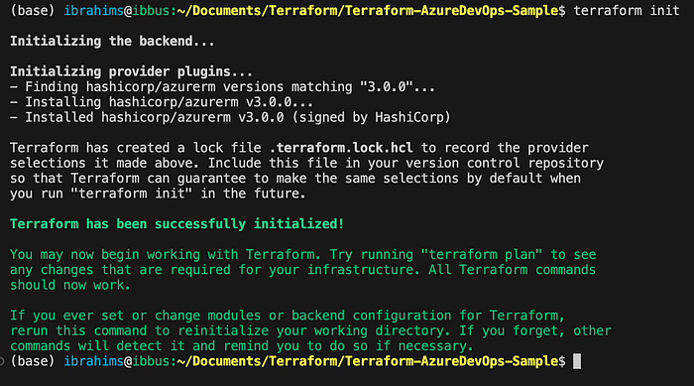

terraform.lock.hclIt captures the versions of all the Terraform providers you’re using.

Generated by Terraform when you runterraform init command.

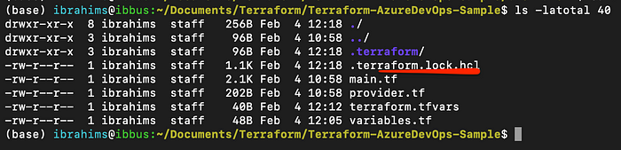

This file serves as a reference point across all executions, aiding in the evaluation of compatible dependencies with the current configuration.

terraform fmt

Theterraform fmt command is used to **rewrite Terraform configuration** files to a canonical format and style. This command applies a subset of the Terraform language style conventions, along with other minor adjustments for readability.



terraform validate runs checks that verify whether a configuration is syntactically valid and internally consistent, regardless of any provided variables or existing state.

terraform validate



terraform plan command creates an **execution plan**, which lets you preview the changes that Terraform plans to make to your infrastructure.

When Terraform creates a plan it → **Reads the current state of any already-existing remote objects** to make sure that the Terraform state is up-to-date.

terraform plan

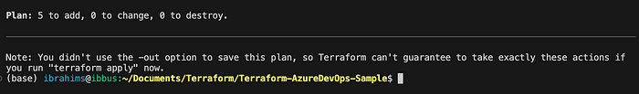

Findout the how many resources create use grep cmd

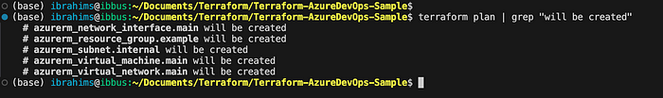

**Apply the Configuration**

Create the AWS resources defined in your Terraform configuration.

Executes the actions proposed in a Terraform plan.

terraform apply (OR)  
terraform apply --auto-approve

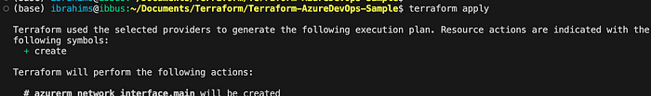

It asks for **confirmation** from the user before making any changes, unless it was explicitly told to skip approval. Finally create a resources.

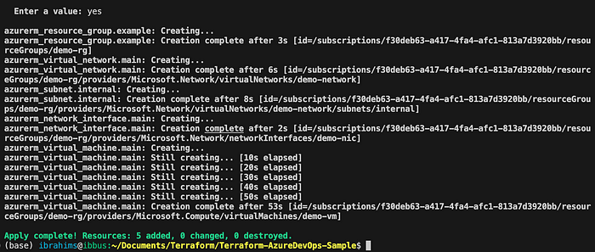

Check the azure portal the resources created?

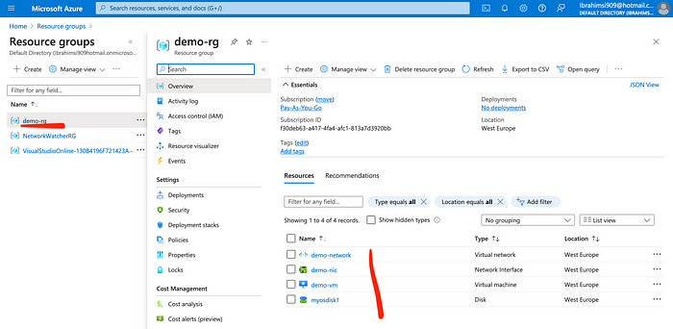

This state is stored by default in a local file named **“terraform. tfstate”** → Terraform uses state to determine which changes to make to your infrastructure.

Recommend storing it in Terraform Cloud to version, encrypt, and securely share it with your team.

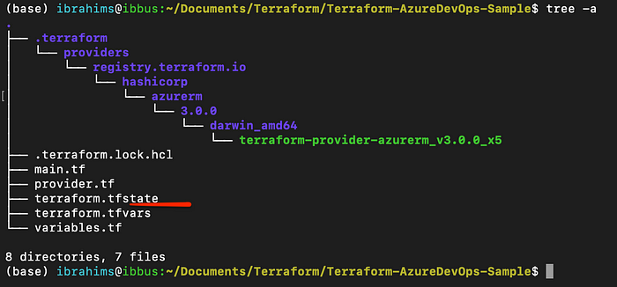

An Azure storage account contains all of your Azure Storage data objects: blobs, files, queues, and tables. The storage account provides a unique namespace for your Azure Storage data that is accessible from anywhere in the world over HTTP or HTTPS.

**Create storage account**

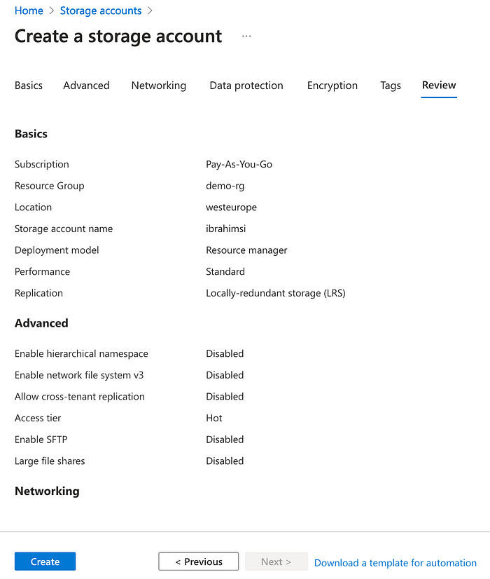

Any container that is used to store products, regardless of its size.

Storage container to host the tfstate file

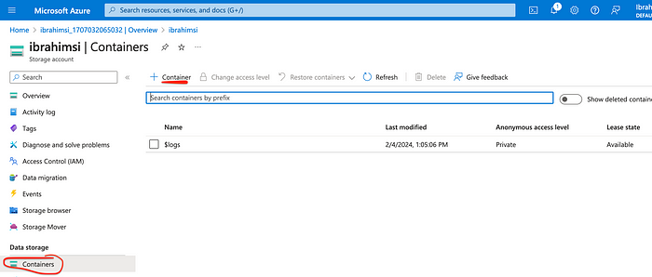

Build infrastructure with terraform configuration, a state file will be created automatically in the local workspace directory named terraform.tfstate.

This tfstate file will have information about the provisioned infrastructure which terraform manage.

Whenever we make changes to the configuration file, it will automatically determine which part of your configuration is already created. And, also it will determine which needs to be changed with the help of the state file.

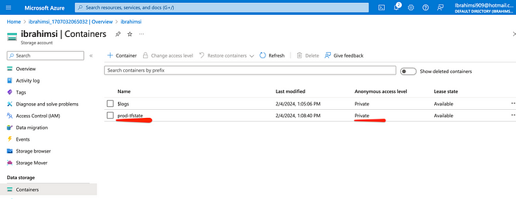

Abackend.tf defines where Terraform stores its state data files. Terraform uses persisted state data to keep track of the resources it manages.

terraform {  
 backend "azurerm" {  
 resource\_group\_name = "demo-rg"  
 storage\_account\_name = "ibrahimsi"  
 container\_name = "prod-tfstate"  
 key = "prod.terraform.tfstate"  
 }  
}

Displays directory paths and (optionally) files in each subdirectory: tree

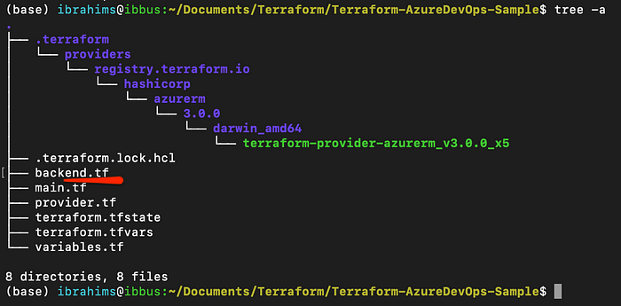

Again initialize the providers the tfstate is already there if migrate

Inside ofprod-tfstate there is no files

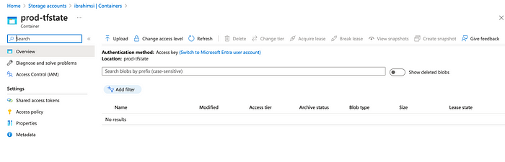

Before init terraform.tfstate file there in local.

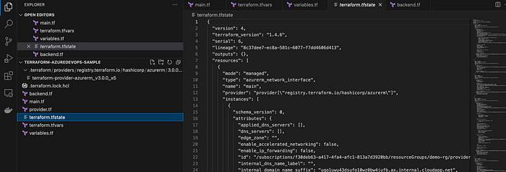

init: Initializes a working directory and downloads the necessary provider plugins and modules and setting up the backend for storing your infrastructure’s state.

terraform init

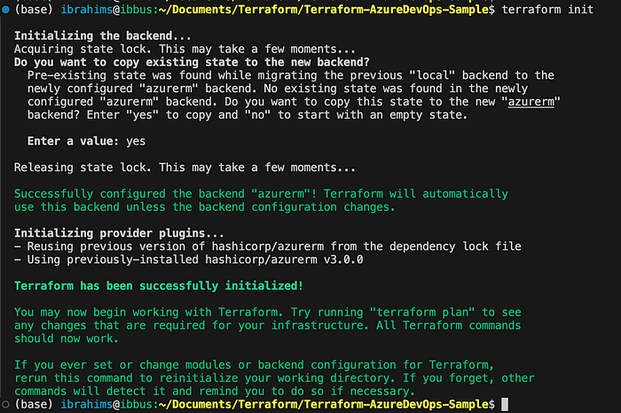

There is no file migrate to remote.

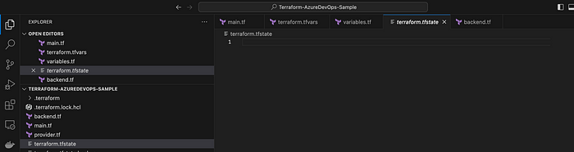

Check azure portal container

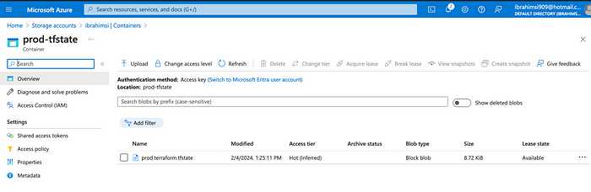

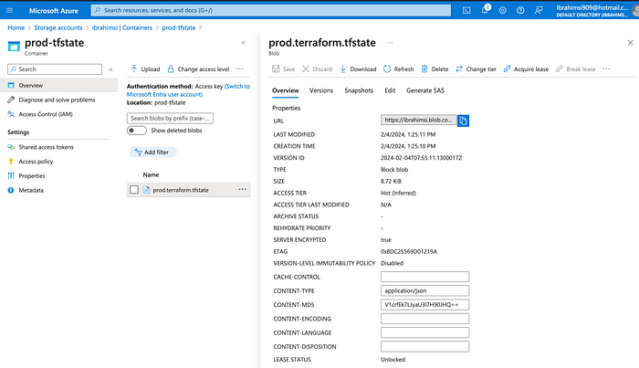

Remotely refer the file → Everytime run the init cmd

Finally destroy the resources

terraform destroy (OR)  
terraform destroy --auto-approve

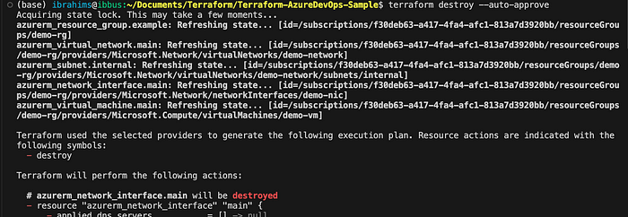

**Azure DevOps CICD Pipeline**

Hashicorp Terraform is an open-source IaC (**Infrastructure-as-Code**) tool for configuring and deploying cloud infrastructure. It codifies infrastructure in configuration files that describe the desired state for your topology.

Terraform enables the management of any infrastructure — such as public clouds, private clouds, and SaaS services — by using Terraform providers.

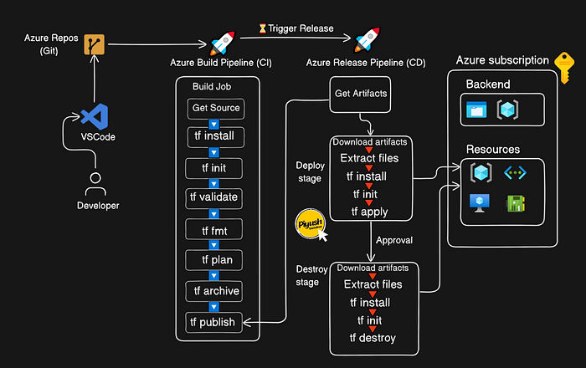

Create a New project

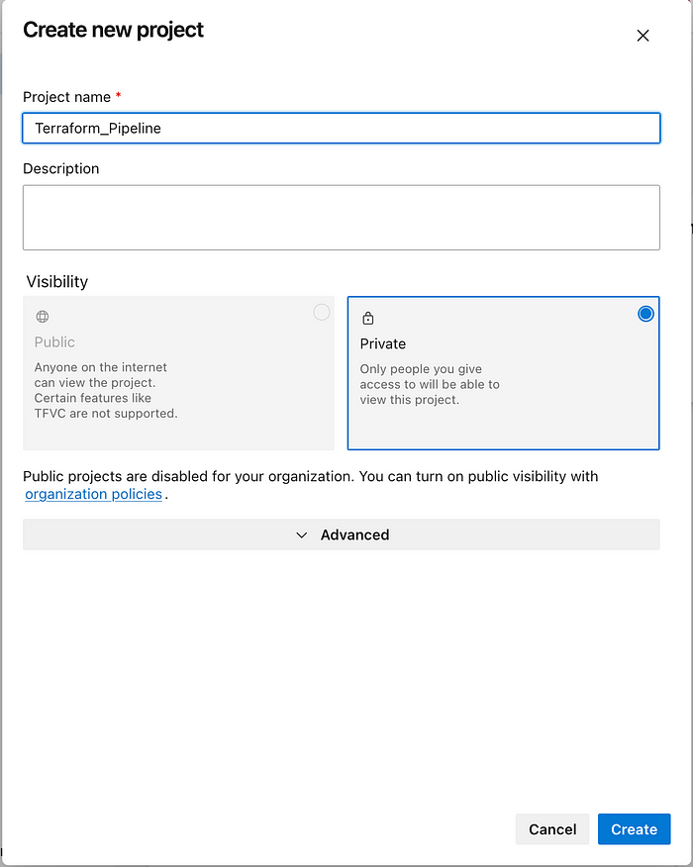

**Import the repository** → <https://github.com/Ibrahimsi/Terraform-AzureDevOps-Sample.git>

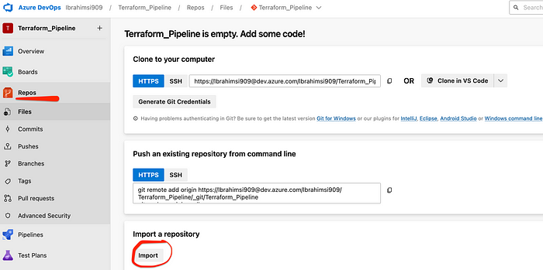

**[GitHub - Ibrahimsi/Terraform-AzureDevOps-Sample](https://github.com/Ibrahimsi/Terraform-AzureDevOps-Sample.git?source=post_page-----b57005a37936--------------------------------" \t "_blank)**

[Contribute to Ibrahimsi/Terraform-AzureDevOps-Sample development by creating an account on GitHub.](https://github.com/Ibrahimsi/Terraform-AzureDevOps-Sample.git?source=post_page-----b57005a37936--------------------------------" \t "_blank)

[github.com](https://github.com/Ibrahimsi/Terraform-AzureDevOps-Sample.git?source=post_page-----b57005a37936--------------------------------" \t "_blank)

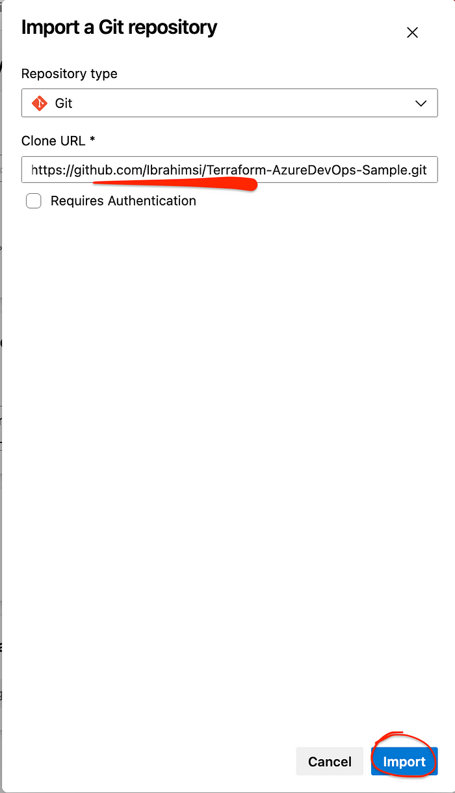

Successfully import the github code

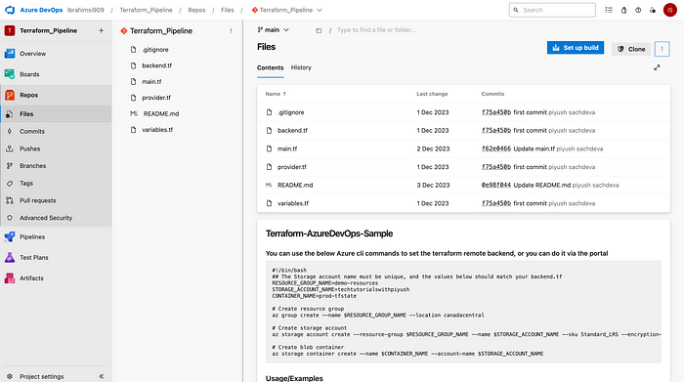

Create a new file

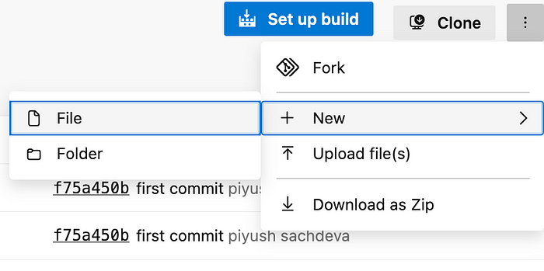

In the name of **terraform.tfvars**

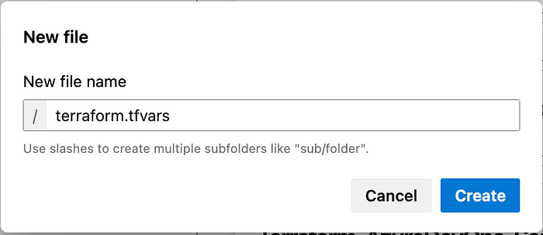

Write the below file

location = "Canada Central"  
prefix = "demo"

Azure Pipelines **automatically builds and tests code projects**. It supports all major languages and project types and combines continuous integration, continuous delivery, and continuous testing to build, test, and deliver your code to any destination. Setup the build pipeline.

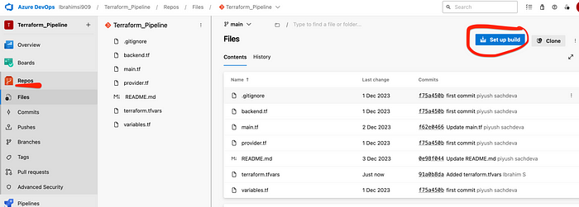

Starter Project **simplifies the setup** of an entire **continuous integration** (CI) and **continuous delivery** (CD) pipeline to Azure with Azure DevOps. You can start with existing code or use one of the provided sample applications. Select the starter pipeline.

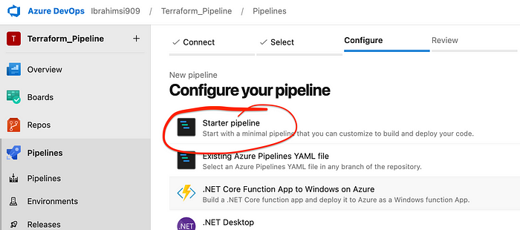

Copt the Pipeline Code

trigger:   
- main  
  
stages:  
- stage: Build  
 jobs:  
 - job: Build  
 pool:  
 vmImage: 'ubuntu-latest'  
 steps:

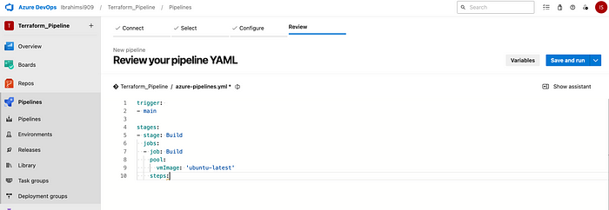

Enable the terraform extension

Terraform enables the definition, preview, and deployment of cloud infrastructure.

Goto Organizational setting → Extension → Browse Marketplace

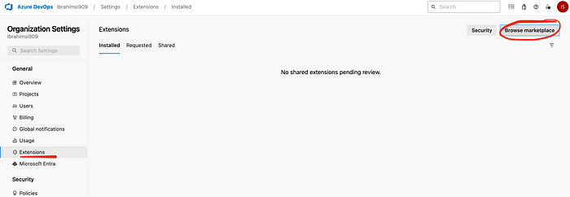

Add **Terraform** Extension

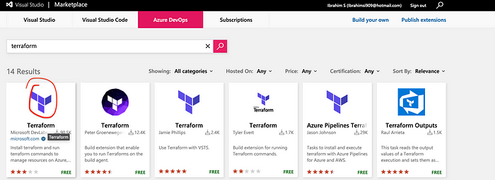

Organization level install the terraform

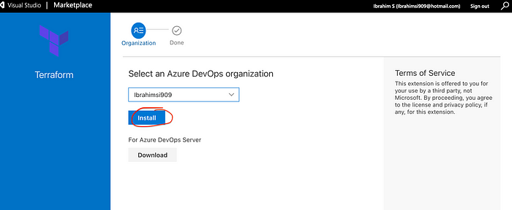

Proceed to the organization

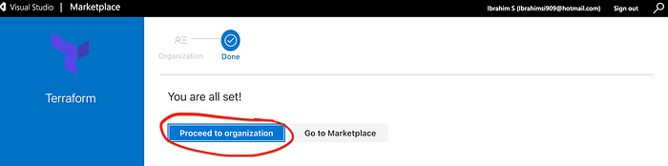

Finally check the extension the terrform add (or) not

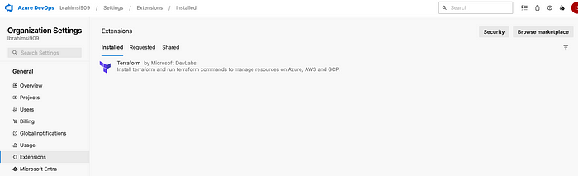

Goto the **Terraform\_Pipeline** project

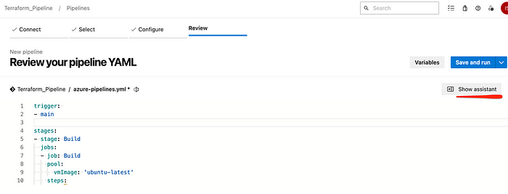

Add Terraform tasks

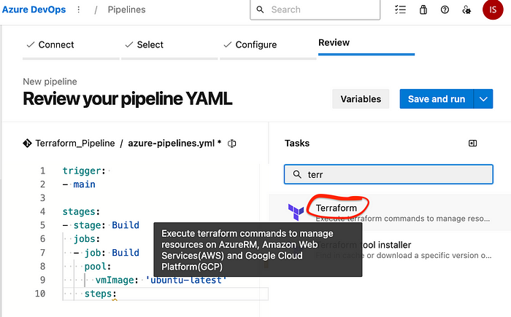

Pipeline variables → Values that can be set and modified during a pipeline run.

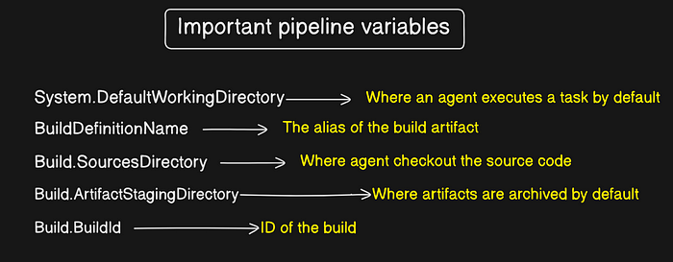

Authorize the subscription → **Person who receives any Service under a valid subscription.**

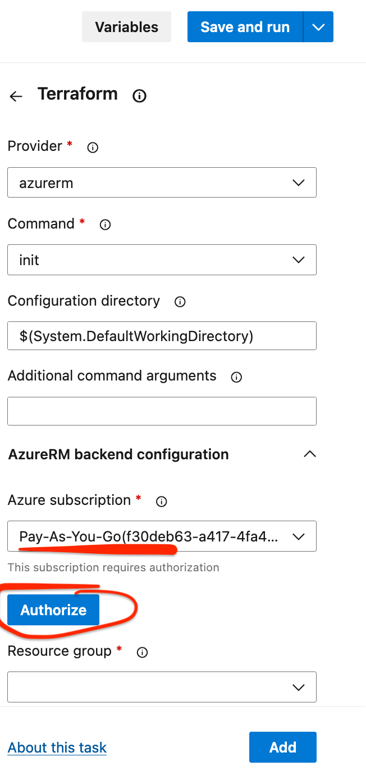

Confirm the subscriptions. Command set to the init mode.

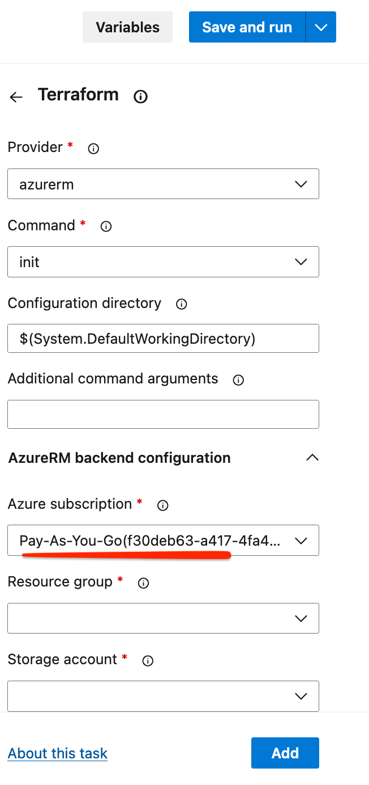

Create a Storage account for Azure Portal. Go to thebackend.tf confirm the storage name.

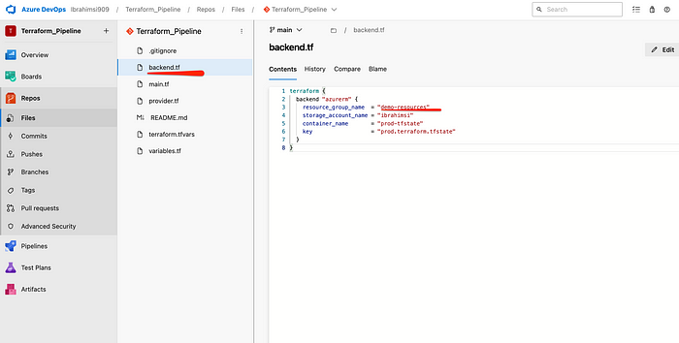

The storage account provides a unique namespace for your Azure Storage data that’s accessible from anywhere in the world over HTTP (or) HTTPS. Create a Storage account.

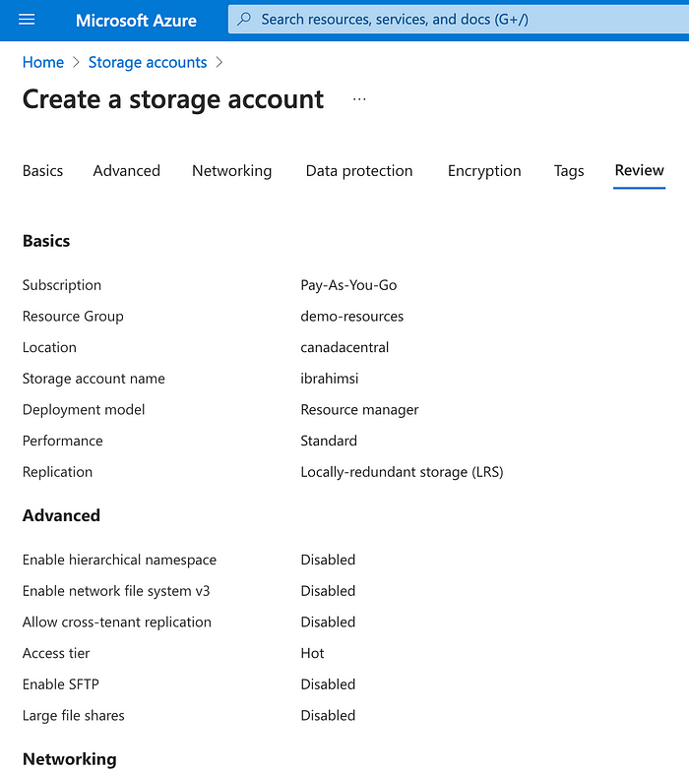

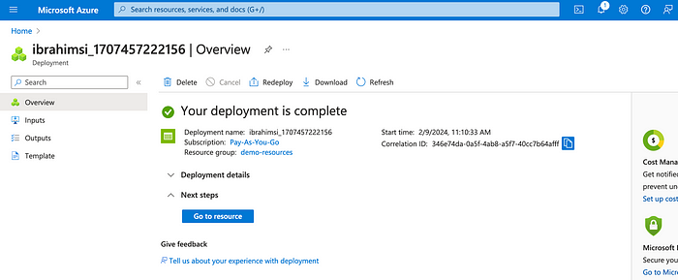

Go to resource → Create a new container

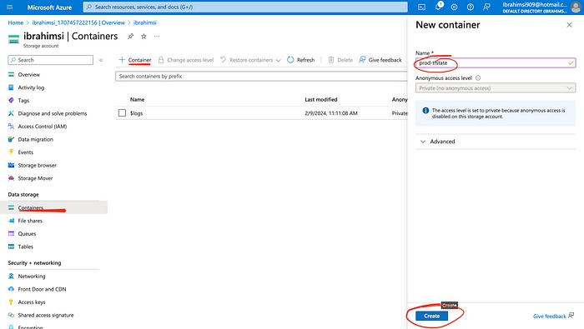

Fillout the terraform pipeline

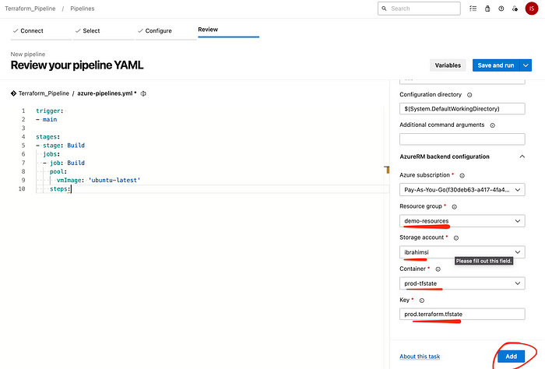

Add to the display name code. Again search the terraform → select validate cmd

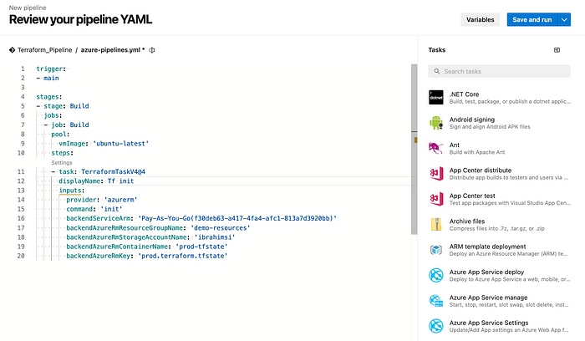

**tf** validate successfully added

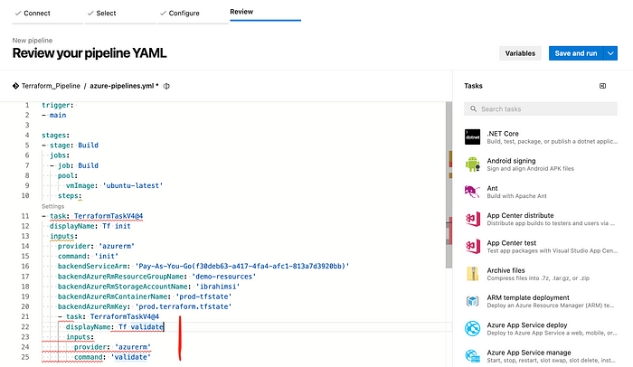

Add another task → fit

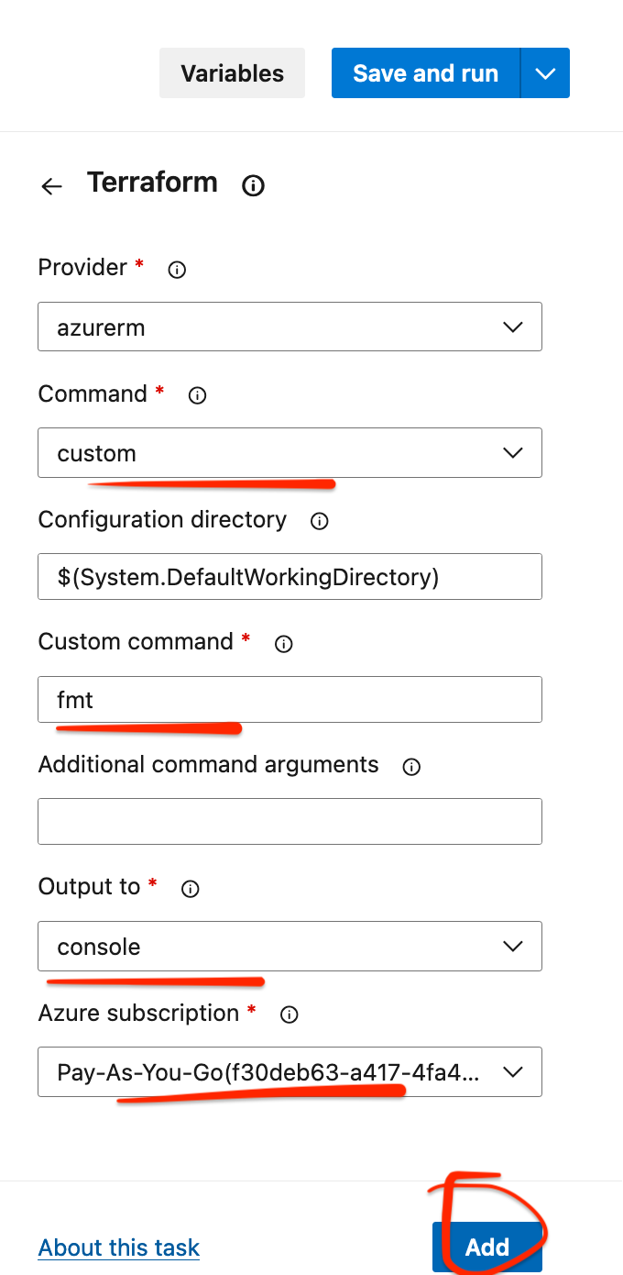

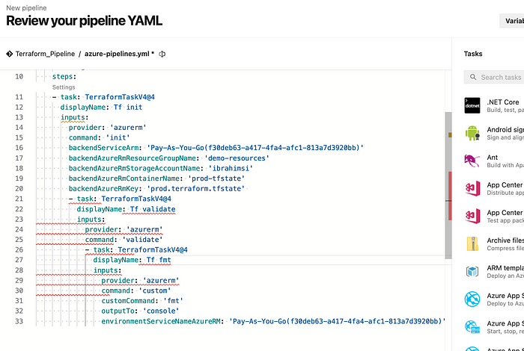

Terraform plan → Creates an execution plan, which lets you preview the changes that Terraform plans to make to your infrastructure.

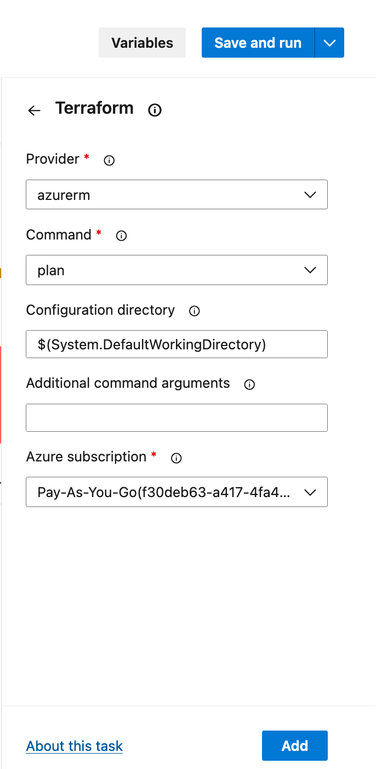

Tf Plan Pipeline Code

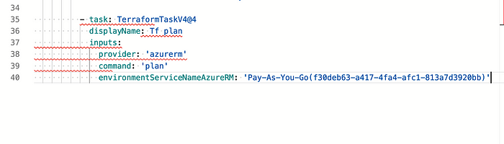

**Archieve build** → It is the overall package.

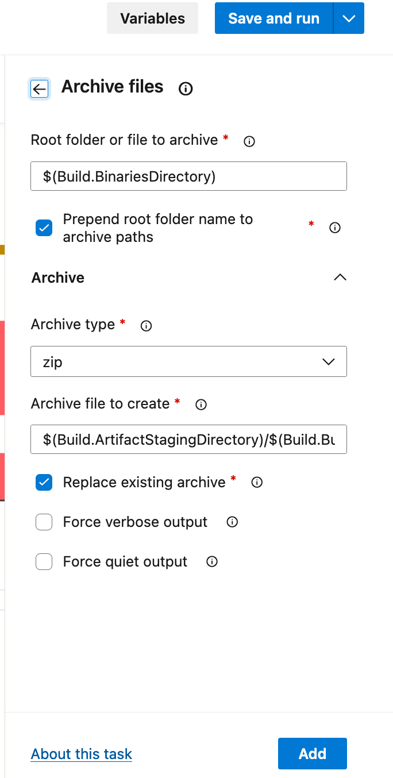

**YAML** is a human-readable data serialization language that is often used for writing configuration files.

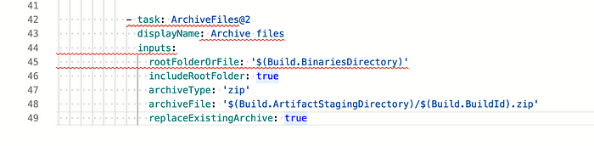

**Publish build artifacts** → Task and can be downloaded with the Download Build Artifact task. And when you publish them.

Artifacts are files created as part of a build process that often contain metadata about that build’s jobs like test results, security scans, etc.

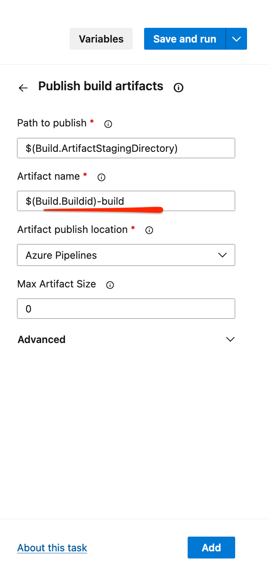

Full pipeline code. 6 tasks is added.

1. Build
2. Tf init
3. Tf validate
4. fmt
5. Tf plan
6. Archieve files

trigger:   
- main  
  
stages:  
- stage: Build  
 jobs:  
 - job: Build  
 pool:  
 vmImage: 'ubuntu-latest'  
 steps:  
 - task: TerraformTaskV4@4  
 displayName: Tf init  
 inputs:  
 provider: 'azurerm'  
 command: 'init'  
 backendServiceArm: 'Pay-As-You-Go(f30deb63-a417-4fa4-afc1-813a7d3920bb)'  
 backendAzureRmResourceGroupName: 'demo-resources'  
 backendAzureRmStorageAccountName: 'ibrahimsi'  
 backendAzureRmContainerName: 'prod-tfstate'  
 backendAzureRmKey: 'prod.terraform.tfstate'  
 - task: TerraformTaskV4@4  
 displayName: Tf validate  
 inputs:  
 provider: 'azurerm'  
 command: 'validate'  
 - task: TerraformTaskV4@4  
 displayName: Tf fmt  
 inputs:  
 provider: 'azurerm'  
 command: 'custom'  
 customCommand: 'fmt'  
 outputTo: 'console'  
 environmentServiceNameAzureRM: 'Pay-As-You-Go(f30deb63-a417-4fa4-afc1-813a7d3920bb)'  
   
 - task: TerraformTaskV4@4  
 displayName: Tf plan  
 inputs:  
 provider: 'azurerm'  
 command: 'plan'  
 commandOptions: '-out $(Build.SourcesDirectory)/tfplanfile'  
 environmentServiceNameAzureRM: 'Pay-As-You-Go(f30deb63-a417-4fa4-afc1-813a7d3920bb)'  
   
 - task: ArchiveFiles@2  
 displayName: Archive files  
 inputs:  
 rootFolderOrFile: '$(Build.SourcesDirectory)/'  
 includeRootFolder: false  
 archiveType: 'zip'  
 archiveFile: '$(Build.ArtifactStagingDirectory)/$(Build.BuildId).zip'  
 replaceExistingArchive: true  
 - task: PublishBuildArtifacts@1  
 inputs:  
 PathtoPublish: '$(Build.ArtifactStagingDirectory)'  
 ArtifactName: '$(Build.BuildId)-build'  
 publishLocation: 'Container'

Save and run the code

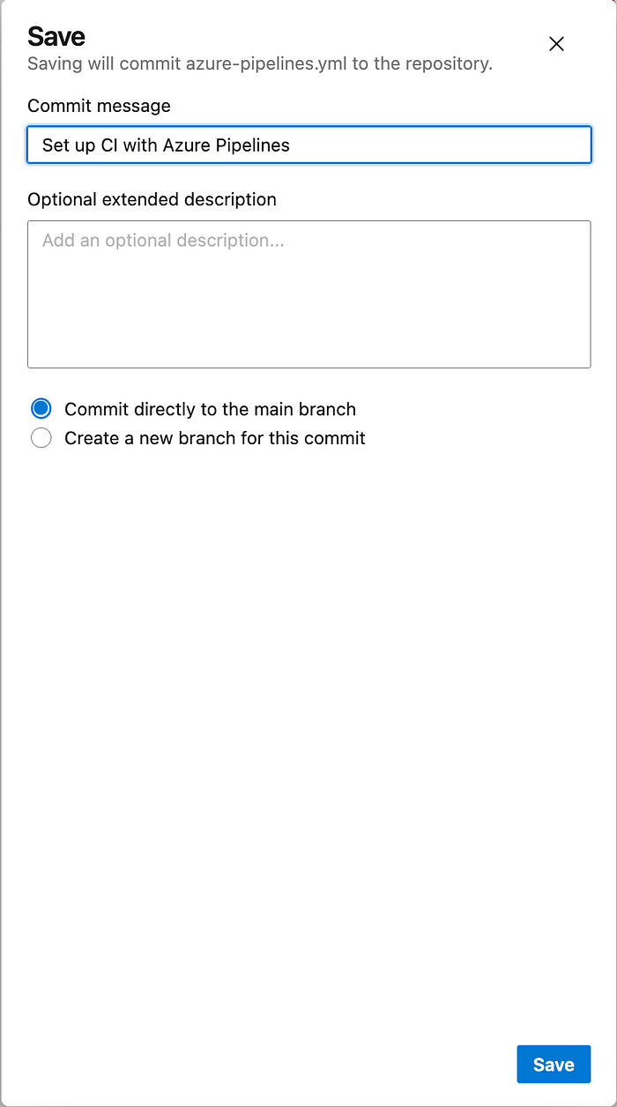

Build job → Pipeline is used to generate Artifacts out of Source Code.

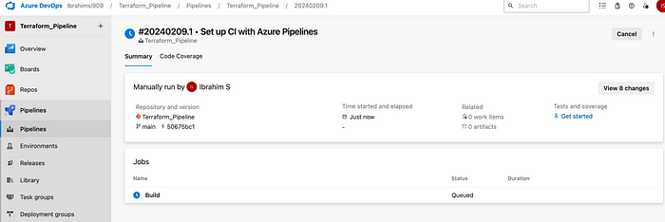

Job approval need → To define a **required** template **approval.**

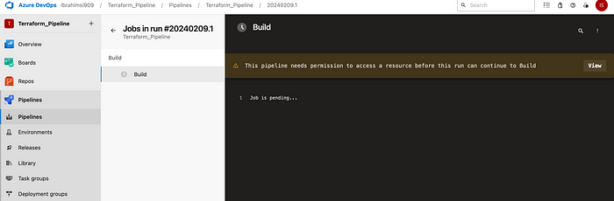

Click on view → Permit → Permit access

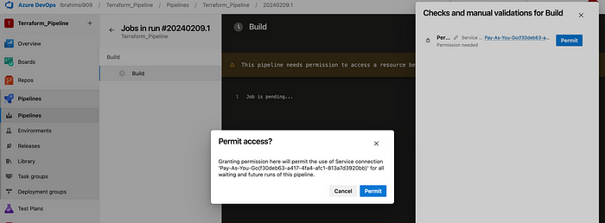

Successfully build the job

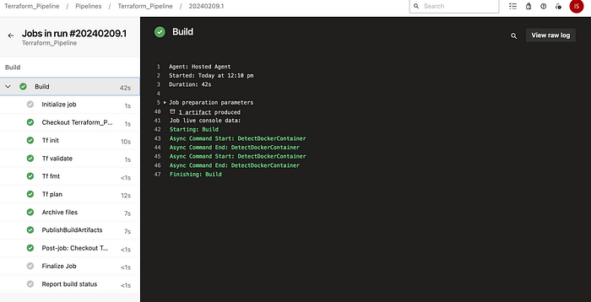

Go to the release pipeline

A Release Pipeline consumes the Artifacts and conducts follow-up actions within a multi-staging system.

New pipeline → Select empty job

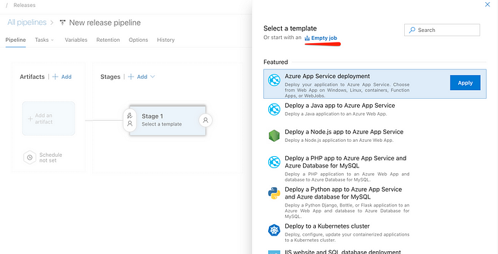

Stage 1 → Deployment

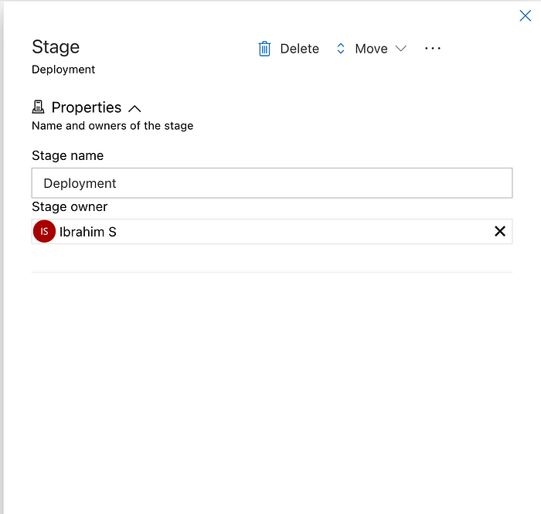

Azure Artifacts enables developers to efficiently manage all their dependencies from one place. Add an artifact.

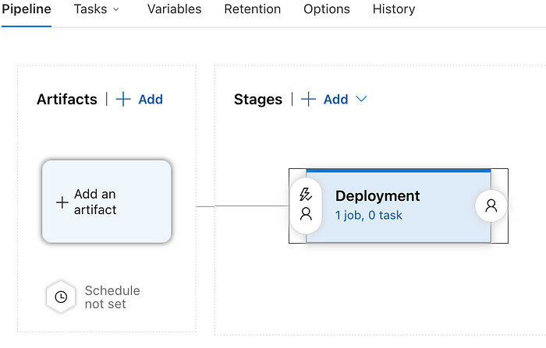

Add build artifact

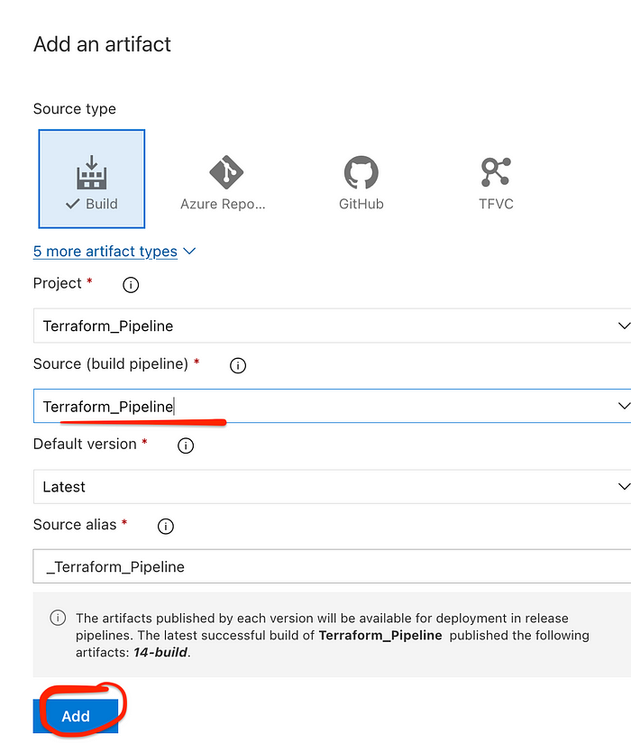

Add the trigger

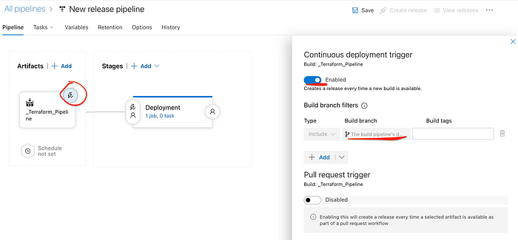

Goto the deployment task

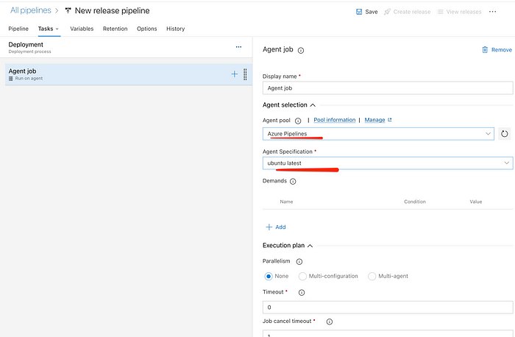

Add another task

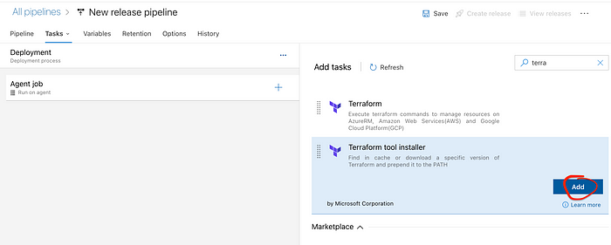

Install the terraform installer

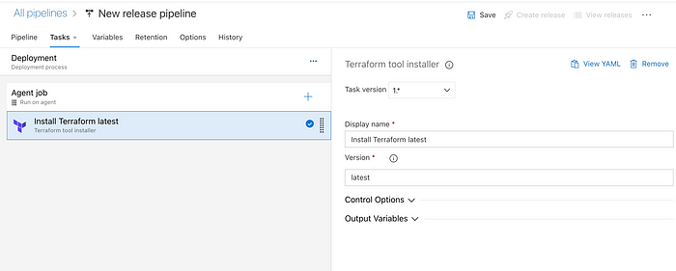

Add another extract files

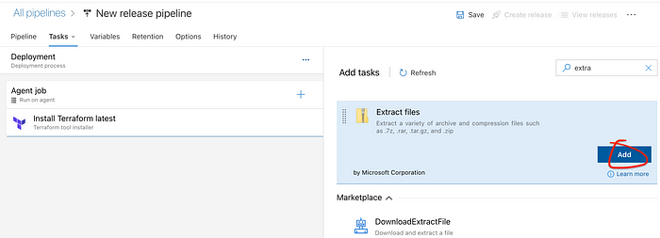

Modified the Destination folder

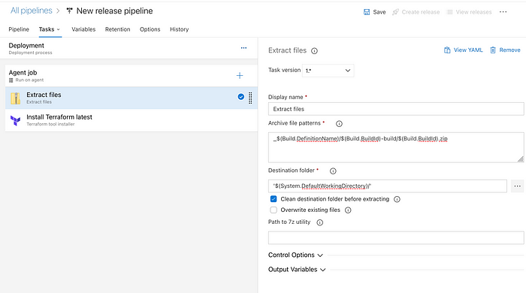

Another task — terraform init

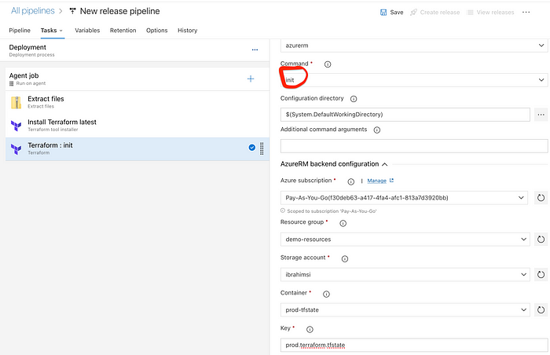

Terraform apply

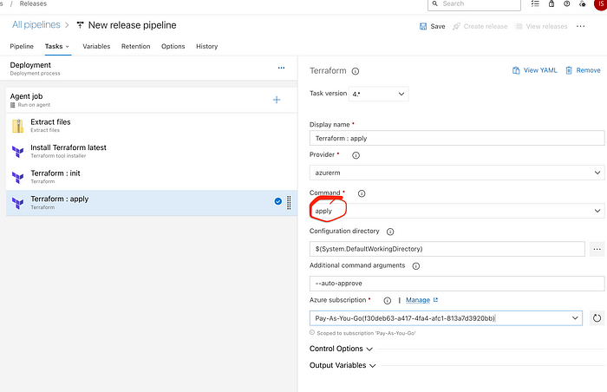

Save the setting

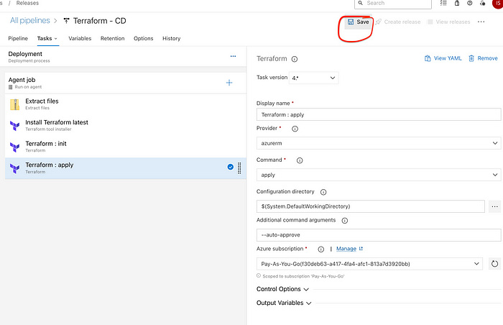

Add one more stage → Clone the stage

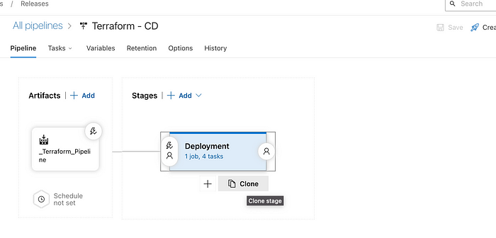

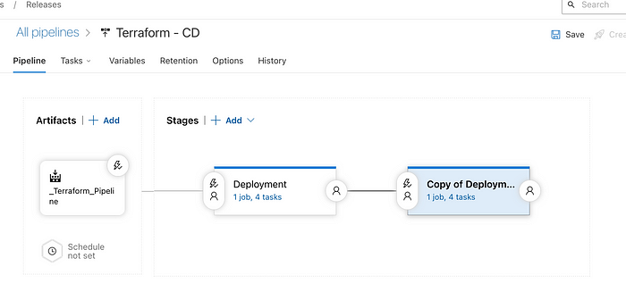

Change the name

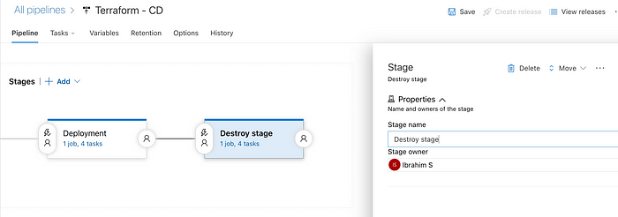

Only one task is modified

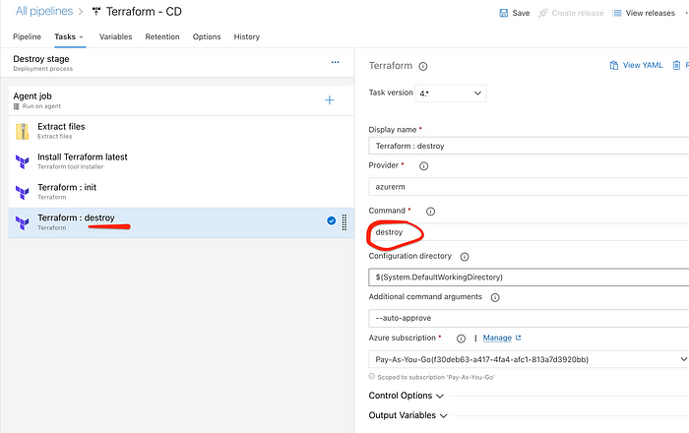

Save the setting

A deployment job is a special type of job. It’s a collection of steps to run sequentially against the environment.

**Pre-deployment approvals**: User must manually sign out after deployment before the release is triggered to other stages.

**Post-deployment approvals**: Team wants to ensure there are no active issues in the work item or problem management system before deploying a build to a stage

Add approval stage before destroy stage → Click Pre-deployment conditions

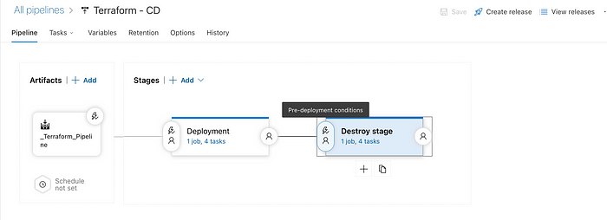

Select the members

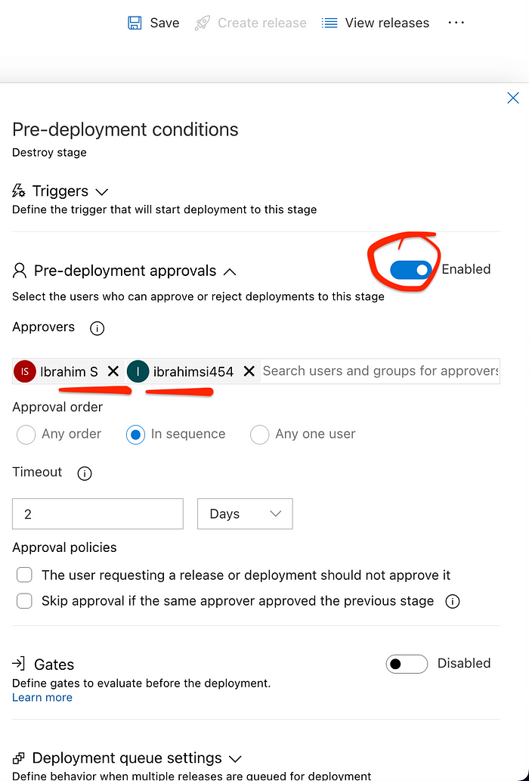

Make the changes git repo let it trigger end to end

Automatically start the pipeline

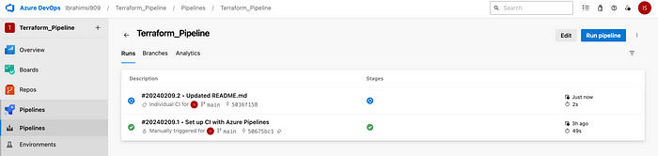

Build pipeline is running

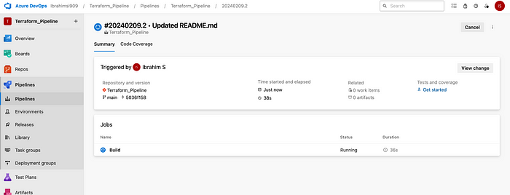

Successful

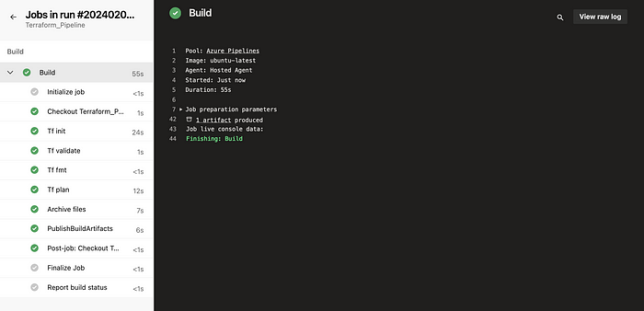

Goto the release pipeline once finish the build pipeline automatically started

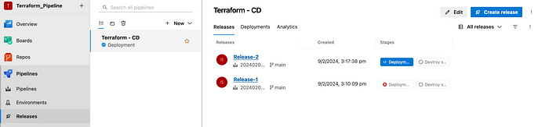

job is running

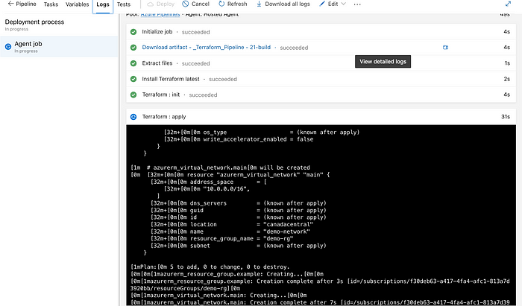

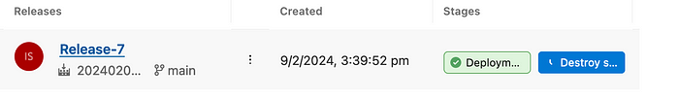

Successfully run the release pipeline

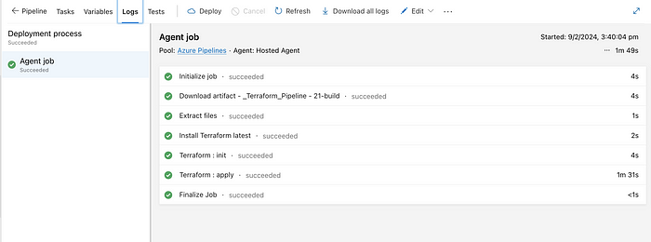

Check the azure portal the resources created or not?

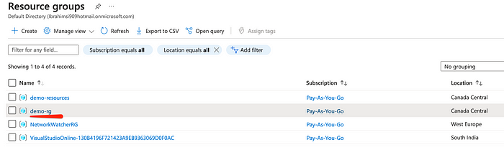

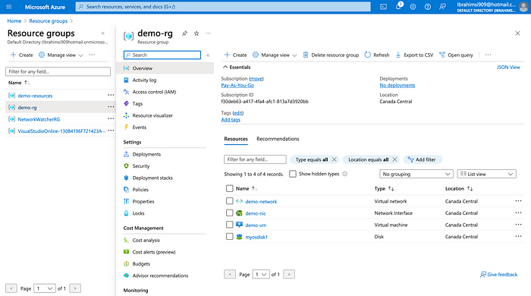

Destroy the resources it need to get approve once approval destroyed

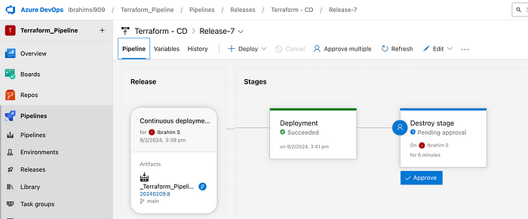

Need to approval → Release pipeline

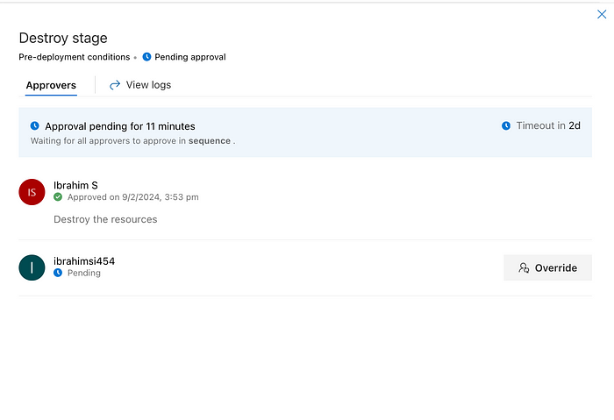

Successful

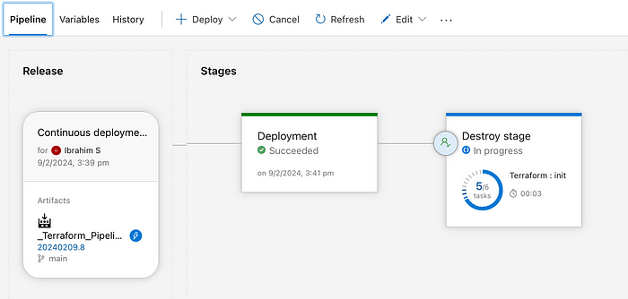

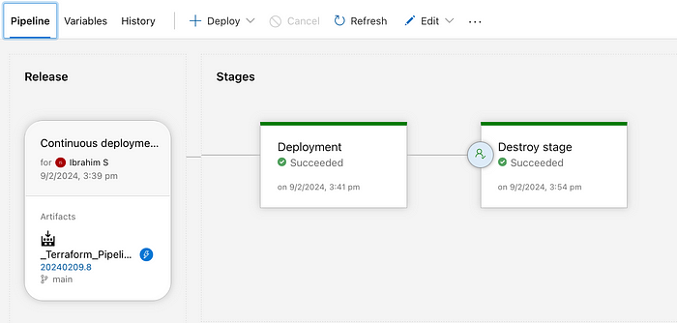

Destroy → Removal of every copy of a data item from an organization.

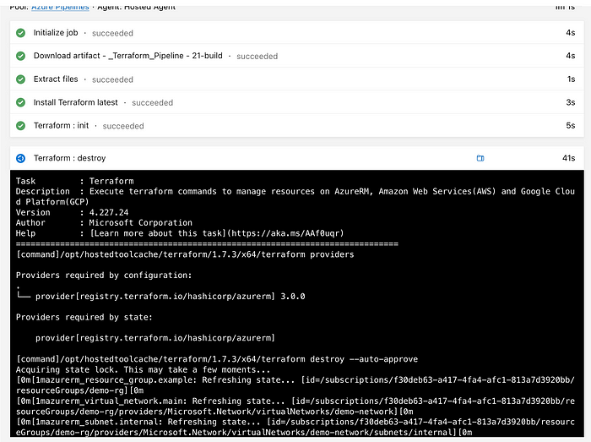

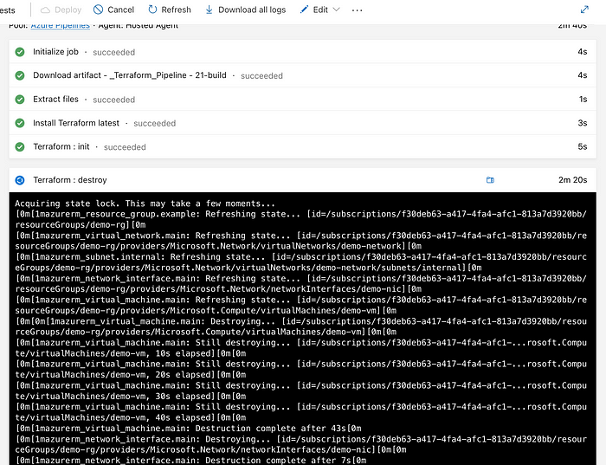

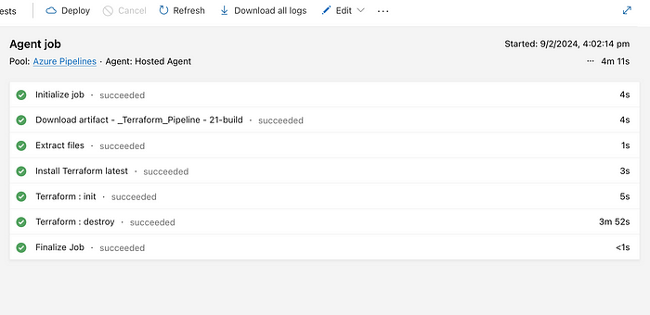

Deleted the resources automatically in Azure Portal.

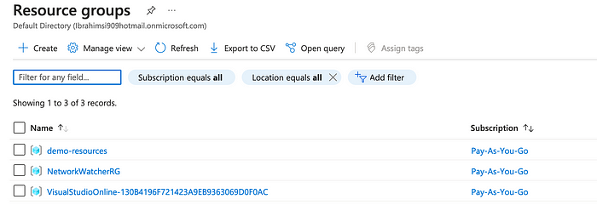

34

